

Melkbosstrand High School
Grade 10 | Computer Applications Technology |  | Term 2  2026
Time: 1 hour | TASK 2  Practical test |  | Marks: 50
Examiner: R. Rabe |  | Moderator: F Pretorius

Instructions and information
- This question paper consists of WORD-PROCESSING and EXCEL-SPREADSHEET questions.
- Note that you will not be allowed to leave the venue before the end of the session.
- Make sure that you save each document using the given file names. Save your work at regular intervals.
- At the end of the examination, you should make sure that ALL the files are saved on the network as explained to you by the teacher. Make sure that all files can be read. Do NOT save unnecessary files/folders. Do NOT hand in duplicate answer files/folders.
- Read through each question before answering or solving the problem. Do not do more than is required by the question.
- During the examination, you may make use of the help facilities of the programs which you are using. You may not use any other resource material.
- Note that if data is derived from a previous question which you cannot answer, you should still proceed with the questions that follow.
- Answer ALL the questions.
- You will receive together with the question paper an examination folder called TEST DATA Gr10, which contains the following files:
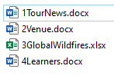
Theme: School Tour
The school is planning to take learners on a road trip to visit some interesting places in South Africa. Apps in the Microsoft Office Suite will be used to help with the administration.
QUESTION 1
A newsletter about the tour has been created.
Open the 1TourNews document.
1.1 Locate the heading ‘Blackwood High’ at the top of the document.
- Change the font of the heading to Calibri (Body), 26 pt.
- Change the font colour of the heading to red. (3)
1.2 Locate the heading “Dear Parents” and move it that it is placed under the heading
“School Trip”. (2)
1.3 Locate the image and the text highlighted in yellow under the heading ‘Blackwood High’.

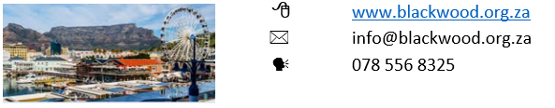
Change the image and the text to appear as shown below, by following the instructions under the screenshot.
Do the following:
- Change the width of the image to 6 cm.
- Remove the highlighting from the text.
- Add the symbol represented by Wingdings character code 56 ( ) in the
position shown above. (3)
1.4 Format the image under the heading ‘Dear Parents’ to display as follows:
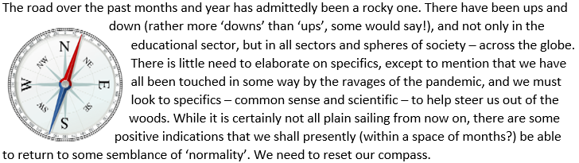 (1)

1.5 Justify the paragraphs under the heading ‘Wrapping up’ that starts with ‘I close this’ and ends with ‘been considered’. (1)
1.6 Locate the en dash under the heading ‘Registrations’.
Change the en dash to an em dash. (1)
1.7 Locate the text ‘Appendix: Places of Interest’ highlighted in yellow.
Format the text with the Title style. (1)
1.8 Locate the text (single paragraph) in red under the heading ‘iSimangaliso Wetland Park’.
Change the case of the text to sentence case. (1)
1.9 Insert automatic page numbers in the footer of the document, in the format
‘Page X of Y’. (3)
Save and close the 1TourNews document. [16]

QUESTION 2
A document was created to promote the Tugela Retreat venue.
Open the 2Venue document.
2.1 Change the page colour to white. (1)
2.2 Change the layout of the document as follows:
- Change the page size to A4.
- Change the right margin to 2.5 cm.
- Change the orientation to portrait. (3)
2.3 Locate the text (paragraphs) in blue ‘We opened ... South Africa.’
- Change the line spacing of the paragraph to Multiple at 1.2.
- Format the paragraph to appear as shown below.
Note: Do not use the space bar to shift or position any text.
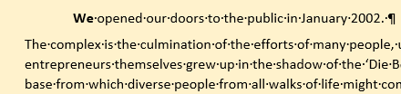 (4)
2.4 Locate the text ‘Enjoy the experience’ towards the bottom of page 2.
Format this text to appear as follows:
 (2)
2.5 Remove the blank page at the end of the document. (1)
2.6 Change all the red text to be italic and bold. (2)
Save and close the 2Venues document. [13]

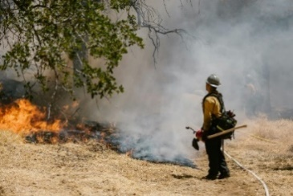
QUESTION 3
SCENARIO: GLOBAL WILDFIRES

Wildfires are a natural phenomenon, yet their increasing severity and frequency highlight the profound impact of human activity on the planet. They remind us of the power of nature and the importance of living in harmony with our environment.

Open the 3GlobalWildfires Excel-spreadsheet document.
Work in the Global sheet
3.1 | Change row height of row 1 to 40pt. | (1)
3.2 | Merge and Centre cells A1 to E1. | (1)
3.3 | Format the cells from C2 to E2 to look the same as cells A1. | (3)
3.4 | Change the data type in column D to currency | (1)
3.5 | In Cell D9 insert a function to display the amount of the most burned hectares. | (2)
3.6 | In Cell D10 insert a function to display the average damaged cost. | (2)
3.7 | In Cell D11 insert a function to determine the total amount of hectares burnt in 2025. | (2)
3.8 | In 2025 only 25% of burns in Africa was insured. In Cell D12 calculate the amount that was insured in Africa. | (3)
3.9 | Rename the sheet to GlobalFires and change the tab colour to red. | (2)
Save and close the 3GlobalWildfires document.
 |  | [17]
Question 4
Open the word-processing document 4Learners and make the following changes:
4.1 | Ensure that there are no spelling errors in the document. | (2)
 | Save the document
4.2 | Save the document as a PDF file named 4Learner New.pdf into your exam folder. | (2)
 | Save and close the document | [4]
GRAND TOTAL: 50

